3.b
We use substitution to make the infinite range into a finite range from 0 to 1.
$$Let z=\frac{x}{1+x}⇒x=\frac{z}{1-z}$$
$$⇒\int_{0}^{∞}{f\left(x\right)dx}=\int_{0}^{1}{\frac{1}{{\left(1-z\right)}^{2}}f\left(\frac{z}{1-z}\right)dz}$$
$$⇒W=C_{1}\int_{0}^{1}{\frac{\frac{1}{{\left(1-z\right)}^{2}}{\left(\frac{z}{1-z}\right)}^{3}}{e^{\frac{z}{1-z}}-1}dz}=C_{1}\int_{0}^{1}{\frac{z^{3}}{{\left(z-1\right)}^{5}\left(e^{\frac{z}{1-z}}-1\right)}dz}$$

3.c
When we take the width of 0.01 and we already get a value of sigma of 5.67*10^-8, which is same as the constant from scipy for 3 significant figures. Therefore is a good approximation

4.a
In order to show the relationship of number of column we took and the difference between our estimated value and the theoretical value. From the graph, we can see that as the number of column increases, the difference doesn’t change.
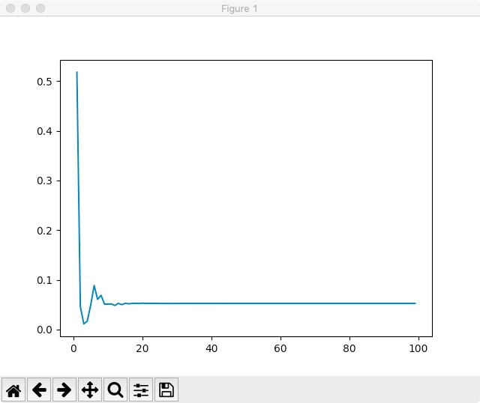
4.b
